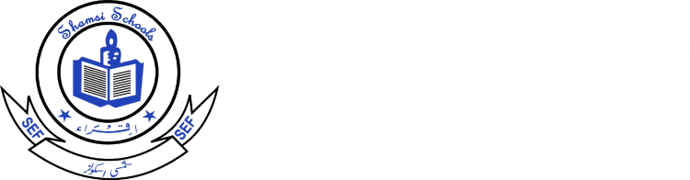
Shamsi School
Shamsi Society Campus Boy’s Shift
Final Term Exam 2025
Class V Subject: Mathematics Time: 3 hours
Student’s Name:__________________ Section: ___________ Roll #: ________________ Date: _____________
Stud

Final Term | Objective Marks | Activity | Subjective Marks | Total  Check by: __________  Re-check by:________
Marks
Obtained
Max. Marks | 25 | 5 | 70 | 100

Objective: (Marks:25)
Q1) Choose the correct answers: /10
- 0.203 × 10 is
- 02.03 b) 2.003 c) 0.203
- Even numbers are multiples of:
- 3 b) 2 c) 8
- Angle measured in
a) Scale b) Protractor c) Degree
- 49 ÷ 10 =
a) 49 b) 4.9 c) 0.49
- A revolution is the mathematical name for a
a) Full turn b) Half turn c) None
- 0.143 L = ________ ml
- 152 b) 143 c) 0.14.3
- Percent means
- Percent b) Out of 190 ⁰ c) Out of 100
- The sum of angles in a triangle is
- 180° b) 360° c) 90°
- Round off to nearest 10: 125
a) 115 b) 130 c) 110
- 1000 more than 93880 is
- 92780 b) 93880 c) 94880
Q2) Name the triangles: /4
a) A triangle with a right angle ____________________________________
b) A triangle that has two equal sides _______________________________
c) A triangle that has three equal sides ______________________________
d) A triangle that has an obtuse angle _______________________________
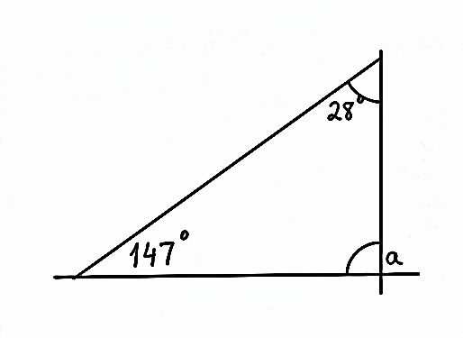
Q3: Fill in the blanks /6
i) Opposite angles of a rhombus are _________
ii) In the given figure, ∠a = _______
iii) Average = ------------------
iv) 0.315 × 100 = ____________
v) 3.2 ÷ 80 = ___________
vi) When two non-parallel rays meet at a common point, an __________ is formed.
Q4: Express each of the following as a percentage: /5
a) $\frac{6}{100}$ = _______
b) $\frac{14}{100}$ = ________
c) 0.2 = _______
d) 0.08 = ______
e) $\frac{5}{10}$ = ________

SUBJECTIVE (70)
ARITHEMATIC (Marks: 48)

Note: Attempt any eight (8) questions. Each question carry equal marks.

Q1. Multiply (any 2)

9.78 × 10 c) 0.9 × 300

8.4 × 1000 d) 2.62 × 2000

Q2. Divide (any 2)

0.15 ÷ 10 = ______ c) 33.6 ÷ 800 = ______

125 ÷ 1000 = ______ d) 8 ÷ 4000 = ______

Q3. Convert (any 2)

a) 2.4 m = ______ cm b) 6 L 853 ml = ______ L
c) 0.094 kg = ______ g d) 1 kg 225 g = ______ kg
e) 0.143 L = ______ ml
Q4) 4.48 kg of flour is mixed with 2.27 kg of sugar.The mixture is then packed equally into 5 packets.
What is the mass of each packet in kg?
Q5) Express each fraction as a percentage (any 2):
a) $\frac{4}{5}$ = b) $\frac{150}{200}$
c) $\frac{3}{4}$
Q6) Mrs. Ahmed bought 6 different dresses.The average cost of each dress was $ 40.70.How much did Mrs. Ahmed pay for the 5 dresses?
Q7) Express each of the following as a decimal (any 2):
a) 18% b) 9%
c) 55% d) 30%
Q8) Ann drinks an average of 1.8 L of water a day.How much water does she drink in 30 days?
Q9) Express each of the following as a fraction in its simplest form (any 2):
a) 50% b) 64%
c) 3% d) 92%
Q10) Rope A is 3.24 m longer than Rope B. Rope A is 5.12 m long. What is the total length of the two ropes?

Q11) The table shows the amount of money Bada saved from January to March. What was Bala’s average monthly savings?
Month | January | Feburary | March
Savings | $ 8 | $ 10 | $ 15

GEOMETRY (Marks 12)
Note: Attempt any two (2) questions. Each question carry equal marks.
Q1) Draw each of the following triangles: (Any one)
(a) Triangle ABC, where BC = 6 cm, AB = 7 cm, and ∠ABC = 110°
(b) Triangle JKL, where KL = 8 cm, JK = 6 cm, and ∠JKL = 90°
Q2) Find the unknown marked angle in each triangle. (Any two)

- c)
g

b)
f
42

Q3) Draw and label each of the following four-sided figures:
- A Rhombus MNPQ of side 4 cm, where ∠MNP = 130° and ∠NPQ = 50°

Q4) Identify each of the following 4-sided figures.
a) b) c) d)
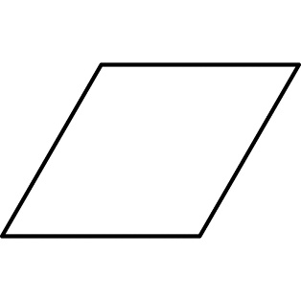
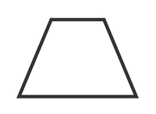

STATISTICS (Marks 10)
Attempt any one (1) question. Each question carries 10 marks.
Q1) What is the probability of getting 6 when a die is rolled?
Q2) Complete the table by writing in events with the following chances of happening:
CHANCE | EVENT
Impossible
Unlikely
Even
Likely
Certain

